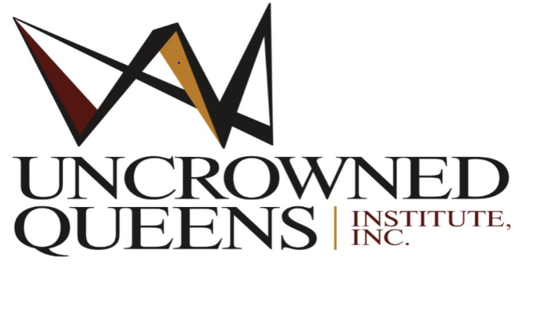
2024 Scholarship Application
Ida Dora Fairbush Criteria /Mary Crosby Chappelle Criteria
ELIGIBILITY REQUIREMENTS:

- African American, Latinx, American Indian, Asian/Pacific Islander, Immigrant high school Senior graduating in the 2023-2024 academic year
- Must have a scholastic three-year average of 85 or above.
- Accepted (or acceptance forthcoming) at an accredited four-year college or university or two-year community college.
- Demonstrated community service.
- Submission of all required information deadline by May 20, 2024, to the scholarship committee.
- U.S. mail to the Scholarship Committee 984 Parkside Avenue, Buffalo, NY.14216
- Or email with all attachments to Uqibuffalo@yahoo.com (Scholarship Committee)

Application Procedure:

- African American, Latinx, American Indian, Asian/Pacific Islander, Immigrant high school Senior graduating in the 2023-2024 academic year

- An official stamp copy of the high school transcript with a Seal from the current school attending
- Submission of Two letters of recommendation, one from school, and one can be from a church or a community organization that you may volunteer for.
- Must have a scholastic three-year average of 85 or above.
- A completed scholarship application
- Submission of all required information by the scholarship deadline of May 20, 2024 by U.S. mail to the Scholarship Committee at 984 Parkside Avenue, Buffalo, NY. 14216
Scholarship Funding distribution:
Scholarship Funds will be awarded after the Institute receives confirmation of the student.
Enrollment in the college of their choice.
- Accepted (or acceptance forthcoming) at an accredited four-year college or university or two-year community college.

Application Deadline –May 20, 2024
- U.S. mail to the Scholarship Committee 984 Parkside Avenue, Buffalo, NY.14216
- Or email with all attachments to Uqibuffalo@yahoo.com ( Scholarship Committee)
- Or upload to email form with all attachments

2024 Two Essay Topics Select one or one can apply to both

- Mary Crosby Chappelle 300-400-word essay on the topic: How did Mary Crosby Chappelle’s multifaceted roles as a teacher, activist, and community builder align with current efforts to promote diversity, equality, and inclusion in education?? – Fully Explain your answer.

- Ida Dora FairBush 250-300-word essay on the topic: Please Imagine that you Interviewed Miss Ida Dora FairBush. What questions would you ask her? What lessons about her life (e.g. her life challenges and successes) After that interview what was inspiring and instructive for you? -Fully explain your answer in detail.

